ASSIGNMENT #1: Values and Variables
1. Declare variables called 'country', 'continent' and 'population' and assign their values according to your own country (population in millions)
2. Log their values to the console
ASSIGNMENT #2: Data Types
1. Declare a variable called 'isIsland' and set its value according to your country. The variable should hold a Boolean value. Also declare a variable 'language', but don't assign it any value yet
2. Log the types of 'isIsland', 'population', 'country' and 'language'
to the console

ASSIGNMENT #3: Operators and Control Structures
1. Calculate the average score for each team, using the test data below.

2. Compare the team’s average scores to determine the winner of the competition, and print it to the console. Don’t forget that there can be a draw, so test for that as well. (draw means they have the same average score)

3. Include a requirement for a minimum score of 100. with this rule, a team only wins if it has a higher score than the other team, and the same time a score of at least 100 points.
HINT: use logical operator to test for minimum score as well as multiple else if blocks.

4. Minimum score also applies to a draw! So a draw only happens when both team have the same score and both have a score operator or equal 100 points. Otherwise no team wins the trophy.

TEST DATA :
#Team MI score – 96, 108, 89
#Team CSK score – 88, 91, 110

TEST DATA (For 3rd Point) :
#Team MI score – 97, 112, 101
#Team CSK score – 109, 95, 123

TEST DATA (For 4th Point) :
#Team MI score – 97, 112, 101
#Team CSK score – 109, 95, 106

Assignment #4: Switch Case
Create a simple calculator using switch statement.
1. accept two numbers from user
2. display the menu to user and accept the input as a sign (operator)
menu ->
+ => addition,
- => substraction
* => multiplication
/ => division
% => mod
** => power
3. display/write the output on the screen. (e.g. Addition = 45)
HINT : use switch case.

Assignment #5: For Loop
write a JavaScript program -
1. to accept a limit (any number) from user
2. convert it into number using parseInt
3. use a for loop to print only even numbers (on the screen) from 1 to given limit.

Assignment #6: While Loop/Do-While
write a javascript program to create a calculator having below features -
1. display a menu to user having below options -
menu ->
+ => addition,
- => substraction
* => multiplication
/ => division
% => mod
** => power
exit => Quit the Program

2. accept two numbers from user.

3. it should perform any arithmatic operations like as per user's
choice.

4. just keep asking the user for input till the time he is
not choosing exit as option.

5. display the output of all the calculations on the screen at last.

[HINT : Switch Case, While/Do-While, if-else]

Assignment #7: functions
write a javascript program -
1. to accept two numbers from user. (start, end).
2. write a function to print prime numbers between two numbers accepted from user.
3. make sure you're passing start and end numbers in parameters only.

Assignment #8: Switch Case, Arrays & For Loop
write a JavaScript program to take input string from user and
count the number of times a alphabet is repeated in the string and then print it
on the screen.

for e.g. if the input string is - prasad

Your o/p should be like below -

p - 1
r - 1
a - 2
s - 1
d – 1

Assignment #9: Arrays In JavaSCript
Find out all the JavaScript array methods and write all of them in notebook along with syntax, description and examples.

Assignment #10: HTML FORMS WITH STYLING
Design the below given form using html & CSS.

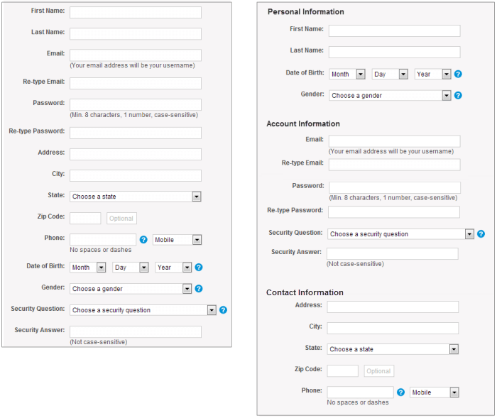

Assignment #11: HTML FORMS WITH CSS STYLING 2
Design the below given form using html & CSS.

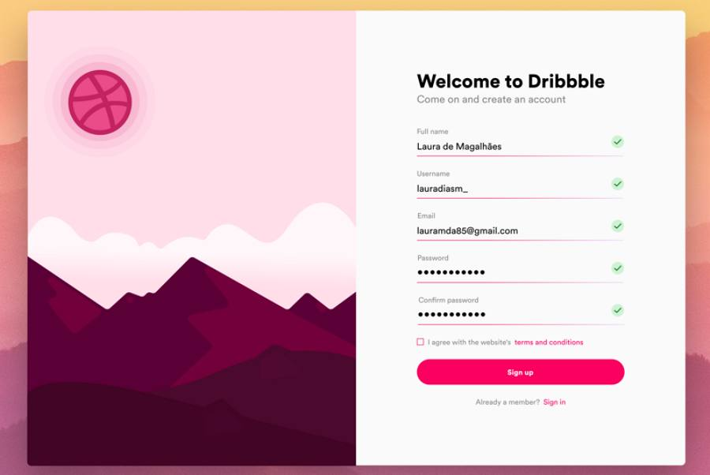

Assignment #12: JAVASCRIPT DOM
Perform the following operations using DOM.
1. create html element and show/append it on page.
2. read the element using dom and print it in alert.
3. read the text of a html element and show it in alert.
4. update the css of a html element using js/DOM.
5. Read Inside Elements/Child Elements Of A HTML Tag/Element

Assignment #13: JavaScript Events
write down all the JavaScript events along with examples

